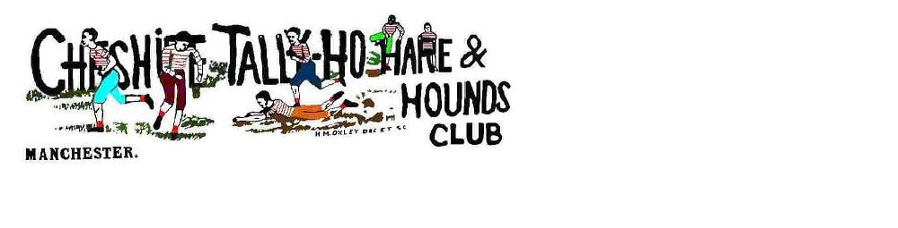

**2025 – 2026 Fixtures**

|  |  |  |  |
| --- | --- | --- | --- |
| **Date** | **Venue** |  | **Trail Layers** |
| **2025** |  |  |  |
| 06 Sept | Forest Hills | Frodsham | Joe Park |
| 20 Sept | Golf Club | New Mills | John Jocys |
| 04 Oct | The Old Hall | Chinley | Adrian West-Samuels |
| 18 Oct | The Royal Arms | Tockholes | Mark Taylor |
| 01 Nov | Devonshire Arms | Peak Forest | John Potter |
| 15 Nov | The Bulls Head | Tintwistle | Steve Murray |
| 29 Nov | Black Bull | Edgeworth | Rick Ridings |
| 13 Dec | The Boars Head | Poynton | Championship |
| 27 Dec | Turkey Trot | Lymme |  |

|  |  |  |  |
| --- | --- | --- | --- |
| **2026** |  |  |  |
| 03 Jan | Tigers Head | Norley | Steve Ruddock |
| 17 Jan | Robin Hood | Rainow | Ian Brown |
| 31 Jan | Cross Keys | Uppermill | Mike Burston |
| 14 Feb | Park Gate Inn | Over Peover | Ian Brown |
| 28 Feb | New Inn | Flash | John Joyces |
| 14 Mar | Lantern Pike | Hayfield | John Wilson |
| 21 Mar | Roman Road | Cambridge |  |
| 28 Mar | The Bulls Head | Tintwistle | Steeplechase |
| 05 Apr | Easter |  |  |
| 11 Apr | Coledale Inn | Coledale | Lakes Weekend |
| 26 Apr | Hartley Folly |  | Steve Murray |
| May | AGM |  | Morley Green |